MASLOWS HIERARCHY OF NEEDS

The consumer behaviour or buyer behaviour is influenced by several factors or forces. They

are: 1. Internal or Psychological factors

2. Social factors

3. Cultural factors

4. Economic factors

5. Personal factors.

The consumer behaviour or buyer behaviour is influenced by several factors or forces. They

are: 1. Internal or Psychological factors

2. Social factors

3. Cultural factors

4. Economic factors

5. Personal factors.

The consumer behaviour or buyer behaviour is influenced by several factors or forces. They

are: 1. Internal or Psychological factors

2. Social factors

3. Cultural factors

4. Economic factors

5. Personal factors.

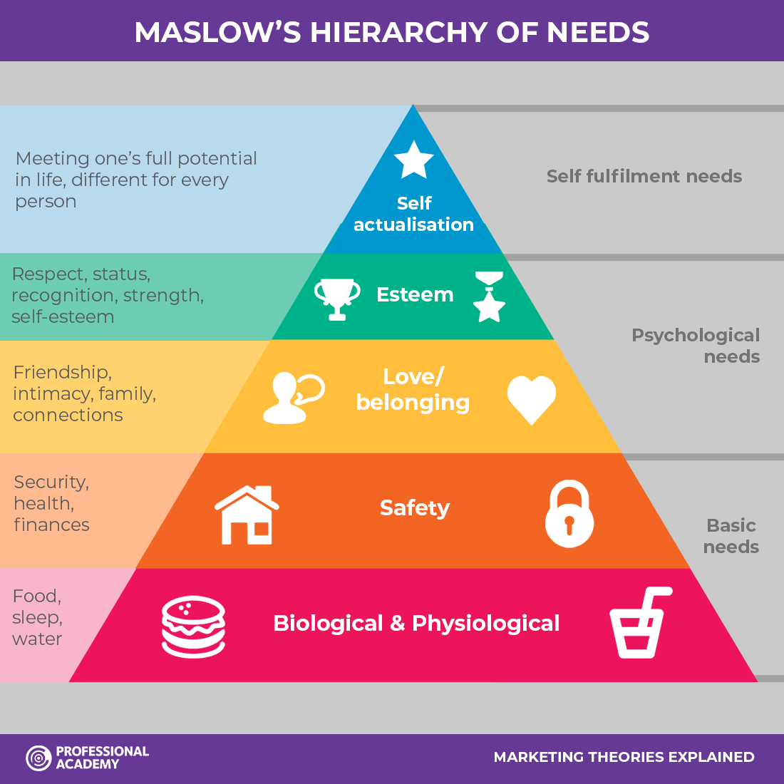

1. **Physiological needs** - these are biological requirements for human survival, e.g. air, food, drink, shelter, clothing, warmth, sex, sleep.

If these needs are not satisfied the human body cannot function optimally. Maslow considered physiological needs the most important as all the other needs become secondary until these needs are met.

2. **Safety needs** - once an individual’s physiological needs are satisfied, the needs for security and safety become salient. People want to experience order, predictability and control in their lives. These needs can be fulfilled by the family and society (e.g. police, schools, business and medical care).

For example, emotional security, financial security (e.g. employment, social welfare), law and order, freedom from fear, social stability, property, health and wellbeing (e.g. safety against accidents and injury).

3. **Love and belongingness needs** - after physiological and safety needs have been fulfilled, the third level of human needs is social and involves feelings of belongingness. Belongingness, refers to a human emotional need for interpersonal relationships, affiliating, connectedness, and being part of a group.

Examples of belongingness needs include friendship, intimacy, trust, and acceptance, receiving and giving affection, and love.

4. **Esteem needs** are the fourth level in Maslow’s hierarchy and include self-worth, accomplishement and respect. Maslow classified esteem needs into two categories: (i) esteem for oneself (dignity, achievement, mastery, independence) and (ii) the desire for reputation or respect from others (e.g., status, prestige).

Maslow indicated that the need for respect or reputation is most important for children and adolescents and precedes real self-esteem or dignity.

5. **Self-actualization needs** are the highest level in Maslow's hierarchy, and refer to the realization of a person's potential, self-fulfillment, seeking personal growth and peak experiences. Maslow (1943) describes this level as the desire to accomplish everything that one can, to become the most that one can be.

Individuals may perceive or focus on this need very specifically. For example, one individual may have a strong desire to become an ideal parent. In another, the desire may be expressed economically, academically or athletically. For others, it may be expressed creatively, in paintings, pictures, or inventions.

## **Maslow’s hierarchy in Marketing:**

If marketers know the wants and needs of their target market (which every good marketer should!) then this can be used as a selling point to influence.

A great deal of research is undertaken to **segment, target and position (STP)** customers by various criteria such as demographics, social class, geographic and so on. From this marketers will have a very specific idea about who their target consumers are and tailor their marketing strategy accordingly.

For example a car manufacturer targeting young families is not likely to focus on the top speeds and luxury items in their advertising campaigns but instead on the cost effectiveness and safety features.

It is important to note that your target market’s level or needs and desires may not stay the same, especially in times of political and economic change. Therefore remember to keep your marketing strategy up to date and relevant.